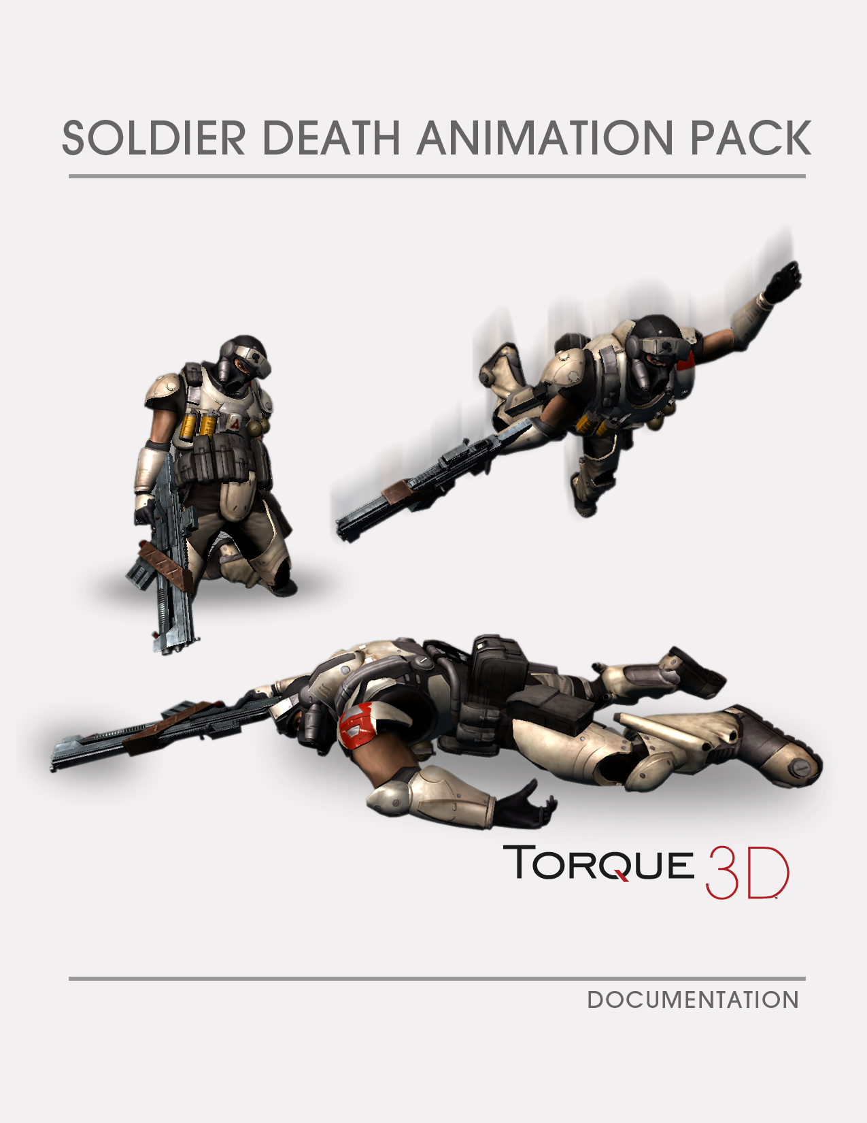

Contents

Description of the Soldier Death Animation Pack 3

Contents of the Soldier Death Animation Pack 3

Included Models and Formats 3

Included Animations 4

Gut Shot Death 4

Head Shot Death 4

Chest Shot Death 5

Drop to Knees Death 5

Flop Back Death 5

Turtle Death 5

Groin Shot Death 6

Back Shot Death 6

Pop Up Death 6

Neck Shot Death 6

Installing the Soldier Death Animation Pack 7

Unzipping the Soldier Death Animation Pack 7

Copying Files into the Correct Directories 7

Using the Soldier Death Animation Pack 8

Conclusion 10

# Description of the Soldier Death Animation Pack

The Soldier Death Animation Pack has been designed specifically for the Soldier model that came with Torque 3D 1.1. The .max and .fbx files of the Soldier animation model are included for artists to use and modify to fit their needs. The meat of the Soldier Death Animation Pack is the included COLLADAtm file and source code for various death sequences.

The art team at GarageGames has designed this pack to provide you with ten different death animations to ensure that your games look as great as possible while maintaining a consistent and reliable multiplayer experience.

# Contents of the Soldier Death Animation Pack

The Soldier Death Animation Pack includes the animations in .max and .fbx formats. There are 10 animations for the Soldier model: Gut Shot, Head Shot, Chest Shot, Drop to Knees, Flop Back, Turtle, Groin Shot, Back Shot, Pop up and Neck Shot.

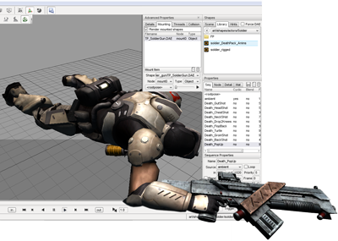We have included the 3D Studio Max files for artists to use to create their own variations. Using these files, they will also be able to see how we have structured our models and animations to get a strong grasp on the art workflow from Max to Torque 3D.

In addition to the 3D Studio Max files, we have included the FBX files so people using other software can have the mesh data available to rig and animate as needed in their chosen digital content creation application.

## Included Models and Formats

The Soldier Death Animation Pack includes 3D Studio Max files for 2010, 2011, and 2012. It also includes FBX files for version release 2010, 2011, and 2012. The Art Pack also includes the .dae COLLADA file and source code. These files can quickly and easily be dropped into the existing Torque 3D missions.

## Included Animations

The included DAE animations are:

* Gut Shot
* Head Shot
* Chest Shot
* Drop to Knees
* Flop Back
* Turtle
* Groin Shot
* Back Shot
* Pop Up
* Neck Shot

|  |  |
| --- | --- |
| Gut Shot Death Watch as the Soldier takes a critical shot to the gut and instantaneously falls to the ground. | Head Shot Death In this animation sequence the Soldier takes a lethal hit to the head and falls rearward to the floor. |
|  |  |
| Chest Shot Death In this scene our Allie takes a mortal shot to the chest triggering him to fly backwards. | Drop to Knees Death Within this sequence our friend falls to his knees after sustaining grave damage. |
|  |  |
| Flop Back Death Be on the lookout of your left flank unlike the Soldier who succumbed to a nasty death after making this mistake. | Turtle Death Watch as our Allie takes a life-threatening blow to the stomach bringing him to his knees. |
|  |  |
| Groin Shot Death Watch as the Soldier takes a critical shot to the groin causing him to fall to the ground to suffer an agonizing death. | Back Shot Death As the famous saying goes "Keep your friends close, your enemies closer" may not have been the best decision for the Soldier in this sequence. |
|  |  |
| Pop Up Death Immediate death from free fall is usually a result of massive brain damage as was the case for the Soldier. | Neck Shot Death Watch as the Soldier dies a slow agonizing death from being shot in the neck. |
|  |  |

# Installing the Soldier Death Animation Pack

The Soldier Death Animation Pack is contained in this ZIP file which can be extracted on any modern operating system. It includes the complete animation source art for the Soldier model as well as the .dae animation file and source code.

## Unzipping the Soldier Death Animation Pack

In Windows, you can extract the zip file by right-clicking on the Solder_Death_Art_Pack.Zip file and selecting *ExtractAll…* Browse to the path where you wish to extract the files. It is recommended that you extract them to your *Documents* directory and then copy them into place to avoid any problems in the future if you make changes to the files.

**Note:** Always make any changes to a copy rather than the original files!

## Copying Files into the Correct Directories

Our team has archived the files in the correct directory hierarchy for the Torque 3D engine. Using the default Torque 3D directory (C:\Torque\Torque 3D Pro 1.1\Examples), copy the *FPS Example* to avoid any problems with the original project. Name this folder with an intuitive title such as **SoldierExample** to test the artwork (see Figure 1).

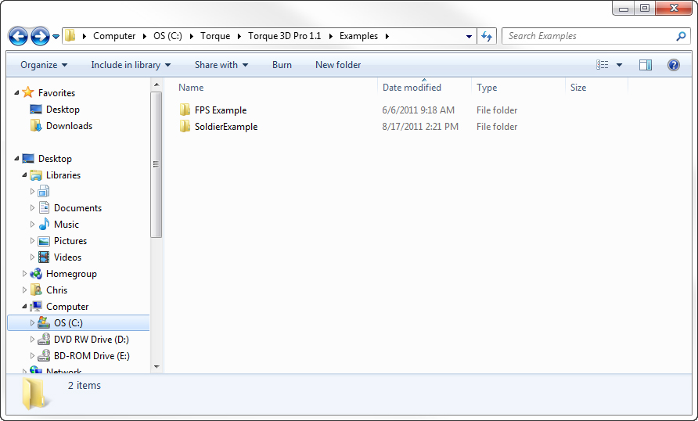

Figure 1: SoldierExample Selection

Open the *SoldierExample* directory and navigate to \game\art\shapes and copy the files from the Soldier Death Aninimation Art Pack’s \art\shapes folder. Accept when prompted to replace files.

# Using the Soldier Death Animation Pack

This section assumes that you have added the *Soldier Death Animation Art Pack* assets to your game directory as required in the previous section. If you have not completed this step, then please add these files to your game’s directory structure so that you will be able to access them correctly.

Navigate to the *SoldierExample* directory where you copied the assets in the previous step. Start *FPS Example.exe* that is inside of the C:\Torque\Torque 3D Pro 1.1\Examples\game directory. Choose the *Blank Room* (see Figure 2).

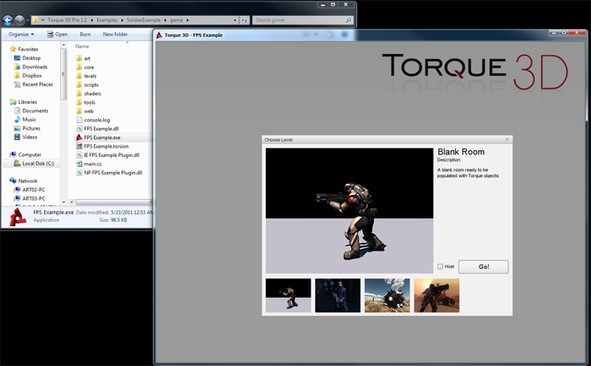

Figure 2: Selecting Blank Room

Once the Blank Room level has finished loading, press F11 to launch into the world editor if you are not in there already. From the World Editor select the **Shape Editor ** in the Toolbar. Once in the **Shape Editor** select the **Library tab** and then open art > shapes > actors > Soldier in the Scene Tree. From there double click on *solder_rigged* in the Scene Tree. This will allow you to view the model with each death animation sequence as you select it in the *Sequence Properties*.

In the top tool bar of the **World Editor** click on the **Toggle Advanced Properties Window** if not already toggled. Under Advanced Properties select the **Threads tab** and uncheck the box next to *Transition Lasts X seconds.*

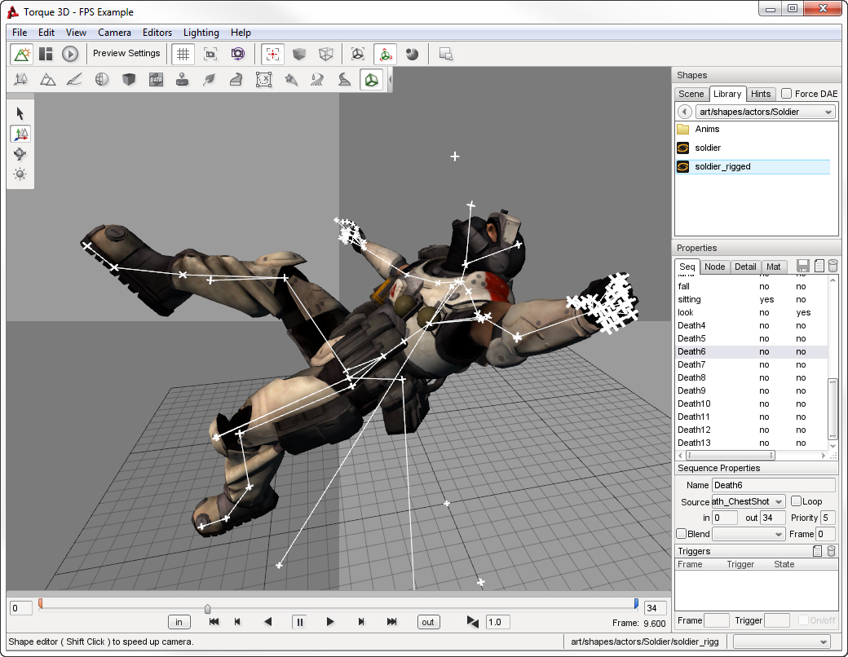

Figure 3: Death6 “Chest Shot” Animation in Shape Editor

Under Properties select **Seq tab** from the Scene Tree. Click on the *Death6* in the **Seq tab** of the Scene Tree. Click the play button  in the animation timeline toolbar in the lower bottom portion of the **Shape Editor**.

## Conclusion

Now that you have a series of death animations for the Soldier, we cannot wait to see the amazing environments and games where you can fit these into. Please do not hesitate to let us know of your successes or challenges at [support@garagegames.com](mailto:support@garagegames.com) as you make use of these assets.